STUDENT NAME: Felistas Njeri
ADM NUMBER: BIT/2024/53014
SCHOOL: School of Computing and Informatics
PROGRAMME: Bachelor of science in information technology
ACADEMIC YEAR: Year 3
SEMESTER:2
LECTURER: Nyoro Michael
PHONE NUMBER: 0716595129
EduManagerPro — Student Management System
WEEK 1:REFLECTION
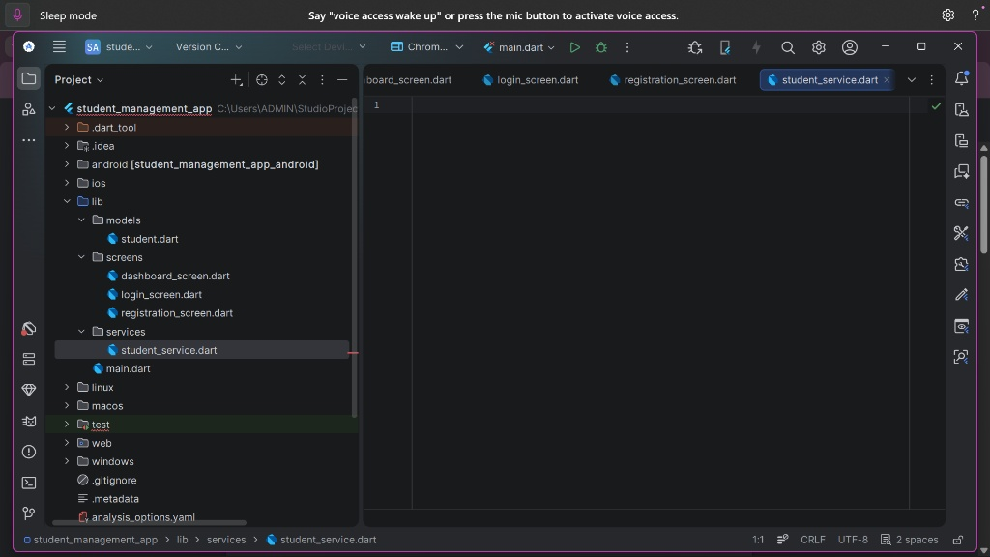

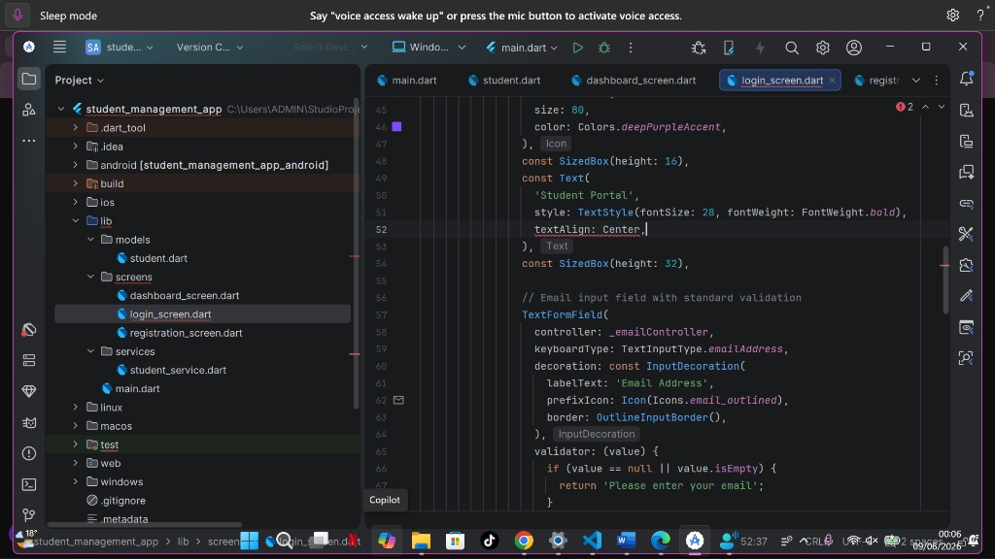
I learned the fundamentals of mobile application development and became familiar with flutter and Android studio . This week gave me a solid foundation for building and managing a mobile application project.
TOOLS USED
Android studio
Flutter sdk
dart

WEEK 2:MOBILE DEVELOPMENT ENVIRONMENT
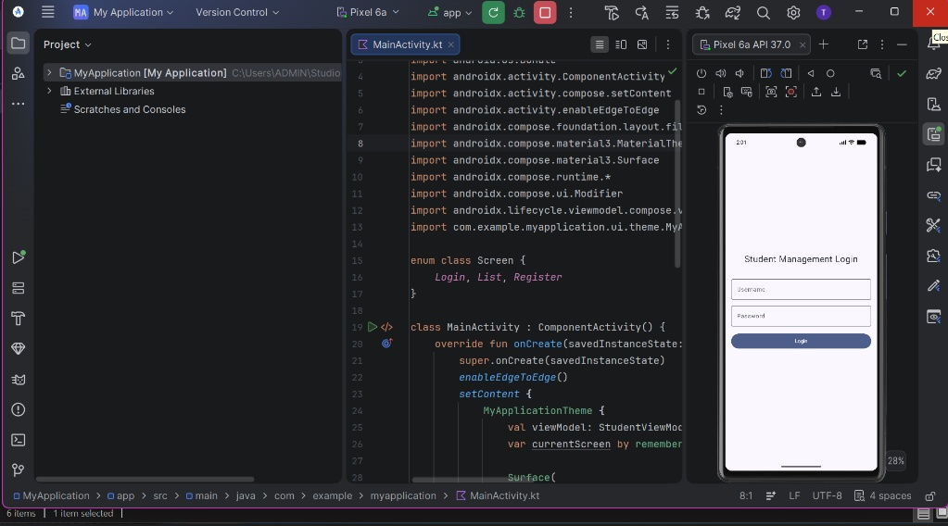
I learned how to set up the development environment and run flutter applications successfully .This improved my confidence in using android studio and prepared me for practical mobile application development.
TOOLS USED
Android studio
Flutter sdk
Dart

WEEK 3:USER INTERFACE DESIGN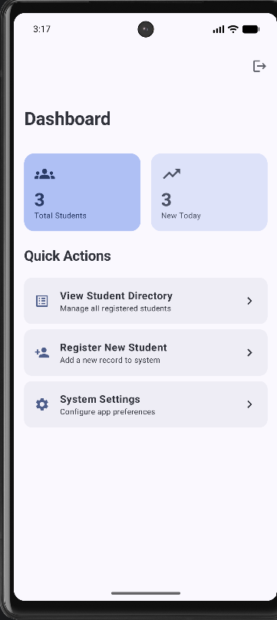
I learned how to design user interfaces using flutter widgets . Creating application screens helped me understand the importance of building simple , responsive , and user-friendly mobile intrfaces.
TOOLS USED
Android studio
Flutter sdk
dart

WEEK 4:EVENT HANDLING AND USER INTERFACE
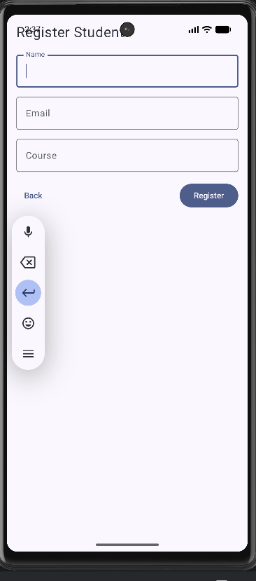

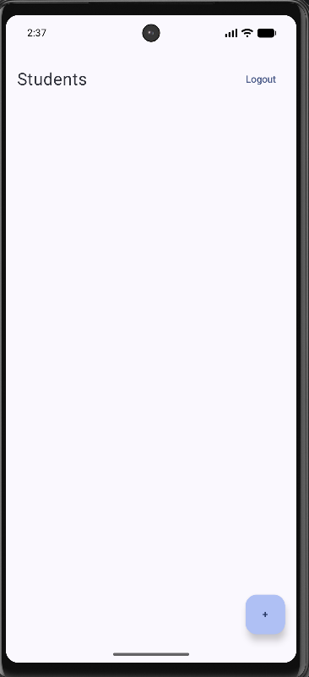
I learned how to handle user interactions such as button clicks and navigation. This improved my understanding of creating interactive mobile applications with a better user experience.
TOOLS USED
Android studio
Flutter sdk
dart
WEEK 5:DATA MANAGEMENT
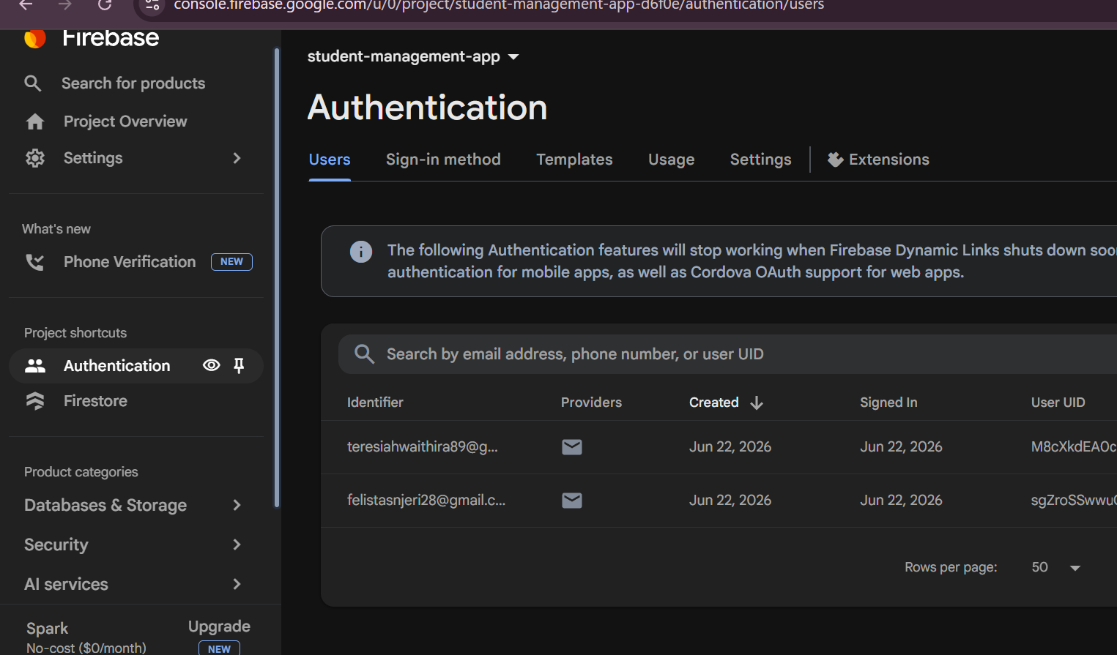

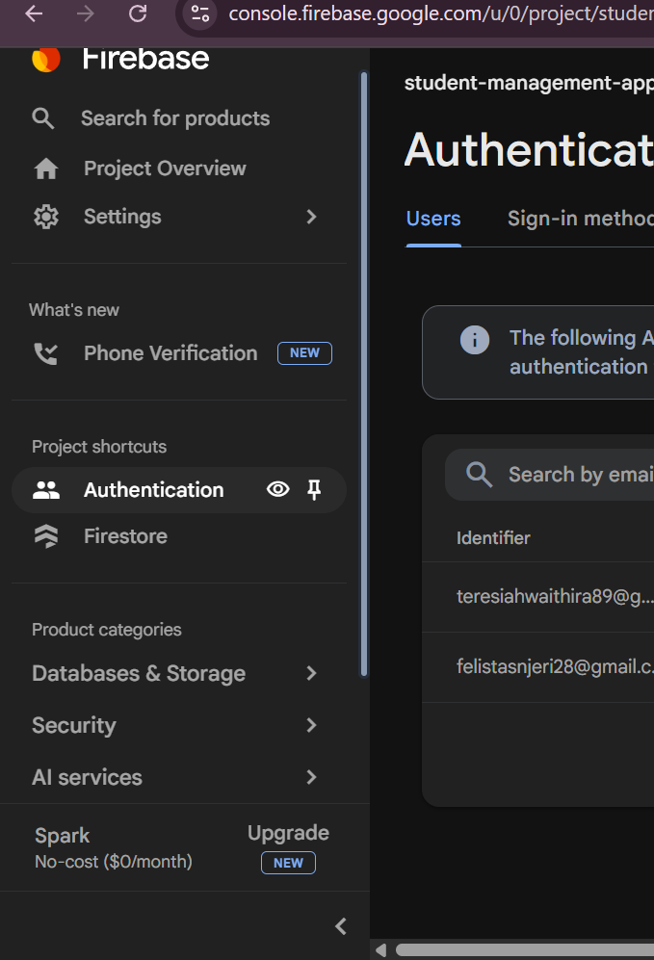
I learned how to manage application data by storing, retrieving and updating information. This enhanced my understanding of data handling and helped improve the functionality of my mobile application.
TOOLS USED
Android studio
Flutter sdk
dart

WEEK 6:NETWORKING AND APIS
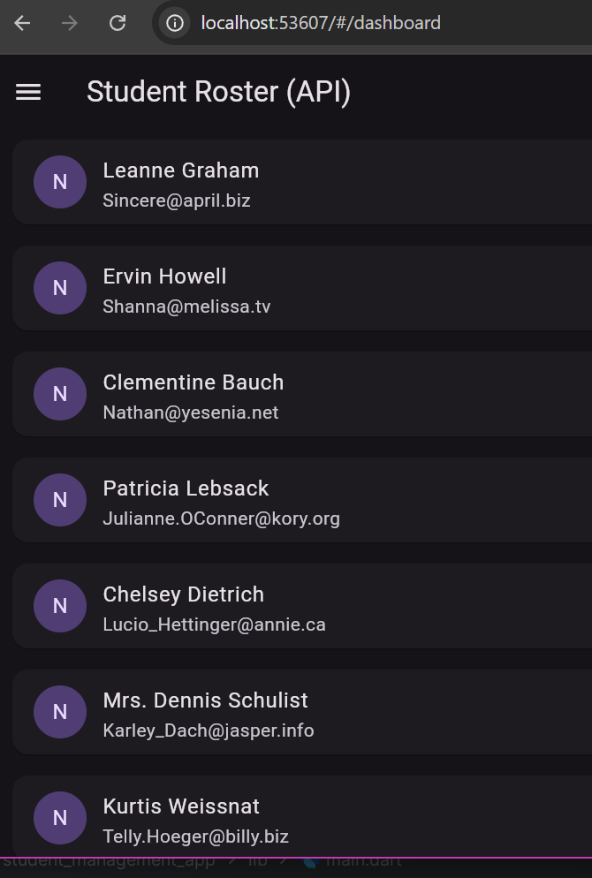
I learned how networking and APIs enable mobile applications to communicate with online services. This week improved my understanding of connecting applications to external data sources and strengthened my practical development skills.
TOOLS USED
Android studio
Flutter sdk
Dart
Android emulator

WEEK 7:APPLICATION ARCHITECTURE
I learned the importance of organizing application components into a clear architecture .This improved my coding practices, made the project easier to manage and prepared me for developing larger mobile applications.
TOOLS USED
Android studio
Flutter sdk
Dart
Andoid emulator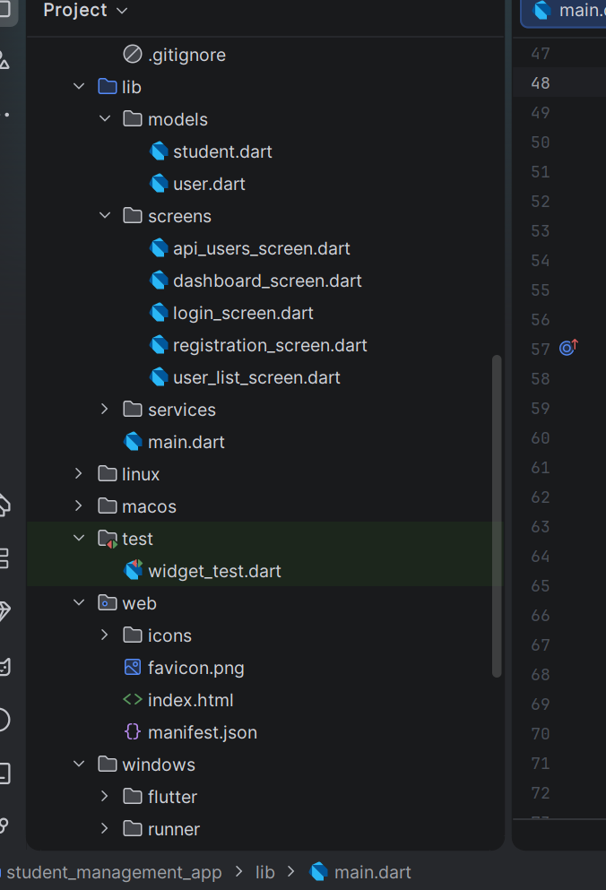
WEEK 8: PROJECT PLANNING USER INPUT AND EVENT HANDLING
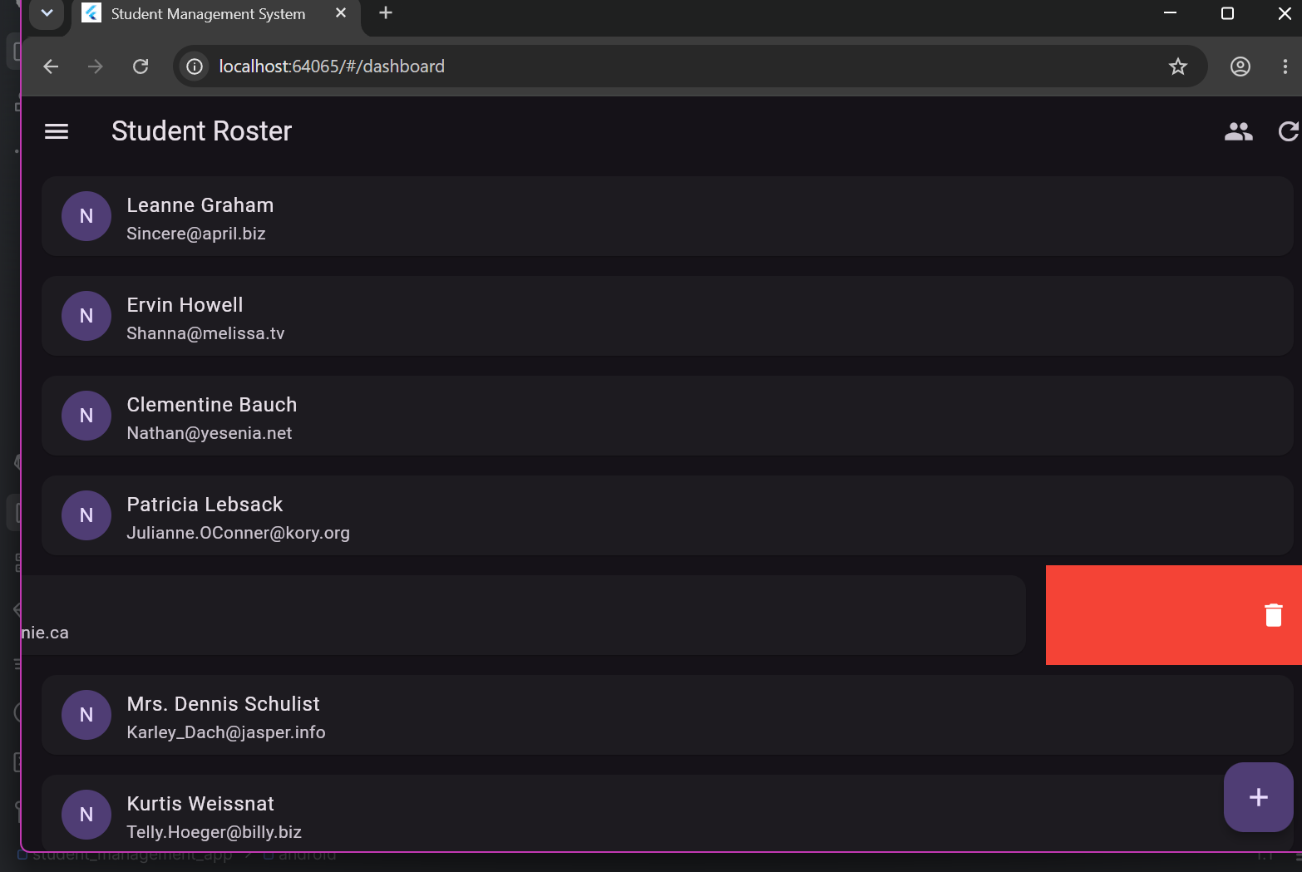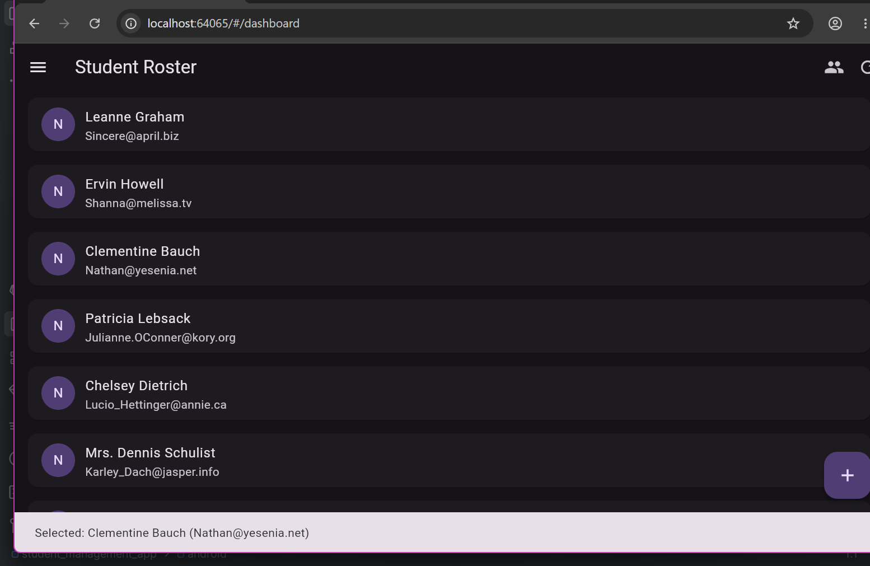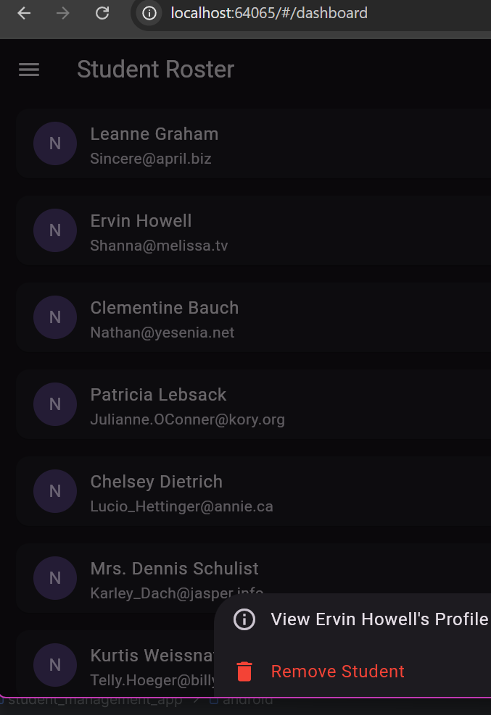
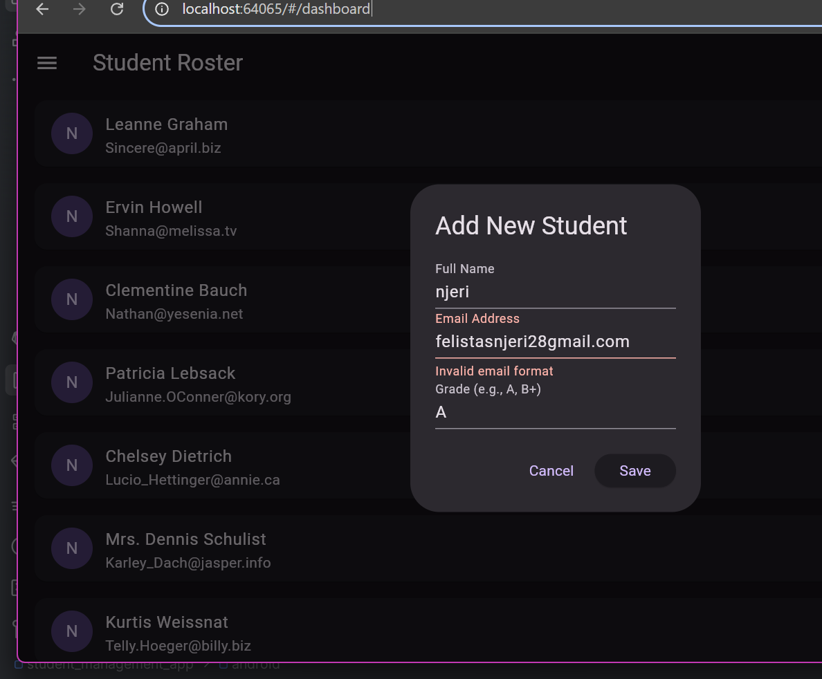
I learned how to implement user input, input validation and touch gestures in Flutter. These features improved my application’s interactivity and enhanced my understanding of event-driven programming and user experience design.
TOOLS USED
Android studio
Dart
Flutter sdk
Android

